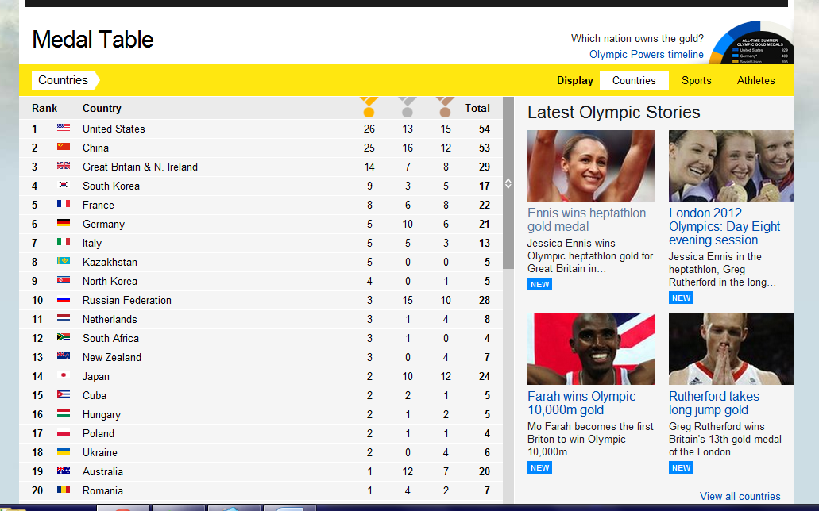

Medal Table – Saturday 4 August
UK – 3rd
Australia – 19th

